True Binding
12th-level Abjuration

Invoke an unspeakable, unbreakable binding ritual that summons forth an entity of the casters' choice, which is summoned in its full form, and bound in chains into an extra dimensional plane that cuts it off from all reality.
The entity cannot break free by any means while this takes place, and when it is trapped within the prison dimension, it's powers and influence cannot reach beyond the prison dimension - if they are a god or power-granting entity, their followers, clerics, paladins, and warlocks or any others that derive powers from the entity immediately lose all powers granted by the entity. No form of extraplanar sense or divination can reach the entity or be heard by them. No magic, item, or power of any form can undo the binding (save for the DIRECT and PHYSICAL influence of an Overdeity), except for the chosen "key".

There must always be at least one "key" that allows the spell to be broken - however, this can come in any form conceivable, and is decided by the casters. Examples of such "keys" are as follows:

- The tears of the mad-god Tharizdun combined with the primordial fires of creation to be anointed on the ritual site.
- Unbound by the efforts of an unborn child.
- By a wish spell cast by the soul-twins of the long lost elven Avariel race.
- The conjoined efforts of Asmodeus and Corellion.
- Stabbing the ritual site with a staff made of pure liquid blood of a deity of magic.
In the process of making such a key, realize that you inadvertently create a prophecy that may one day be fulfilled.
These keys can only be used at the original site of True Binding and cannot be used via far away means or magic.

Casting time: 7 days Range: Special (see description)
Duration: Until dispelled Casters: At least 9

Components:

Verbal
Spoken in Trueword, at the end of the 7 day ritual.
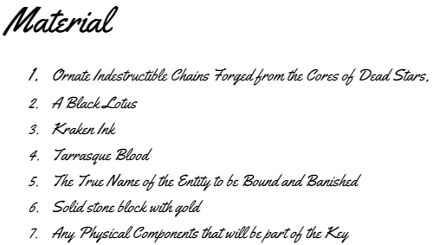
Oh Creature of this Omniverse,we few deem existence would be better without your further interference, I hereby banish thee from here you will watch and are forbidden from interacting with this existence until free once more
Support Chant:
Vercinti Fifer Von Hamalie

Somatic
See Procedure

Carve the True Name into a solid stone block, and fill in the carved out bits with Gold.

Entity Type | Required Sacrificed Hitpoints
Extraplanar Creature (Solar, Balor, Pit Fiend etc.) | 500 hp
Demigod or Quasideity | 1,000 hp
Lesser Deity | 1,500 hp
Greater Deity | 2,000 hp

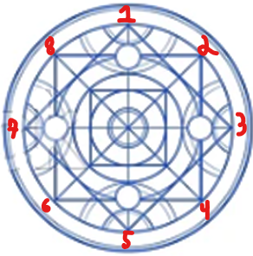
Procedure
- Main Castor: Take the Black Lotus and grind it into dust, Mix with the Kraken Ink and Tarrasque Blood. Take this mixture, and in a 120 ft circle draw the provided sigil.

- All casters stand in the runic circle painted on a flat surface.
  - Main Caster: Position yourself at the top of the circle
  - Castors 1 - 8, position yourselves around the points of the squares
- To begin the casting of the spell all casters speak the true name of the entity of your choice, which appears within the 120 foot circle between all casters.
  - Main Castor: Will begin to float, you must maintain total concentration throughout the whole process.
- At this point all casters begin to chant the support mantra, the chains will rise and bind the entity.
- For the first 24 hours All Support Casters must chant the Support Mantra, this will complete binding the entity to the location for final binding.
- The first 72 hours (Inclusive of the 24 hr chant) the magic binding will erode, requiring a number of casters to continually redraw the circle
  - Main Caster: Maintain concentration
  - Casters 1,3,5,7: Rest
  - Casters 2,4,6,8: Redraws circle
- After 72 hours, the circle will imprint itself onto the surface and glow, and will no longer need to be redrawn.
  - Main Caster: While maintaining concentration speak out the Key
  - Casters 1,3,5,7: Using the Component Ink, write in 4 languages the key spoken by the Main Caster, in the Circles in front of them.
  - Casters 2,4,6,8: Rest

- Once the Key is inscribed into the spell circle, all Support Casters will begin to apply support enchantments to the binding chain. All spells must be upcast to level 10, each spell will take all the energy you can use for the day, so each castor set can only cast one a day.
  - Casters 1,2,3
    - Planar Binding
    - Maximilian's Earthen Grasp,
    - Entangle,
  - Casters 4,5,6
    - Web,
    - Black Tentacles,
    - Watery Sphere,
  - Casters 7,8
    - Whirlwind
    - Bones of the Earth
    - Wall of Fire

  - After the final Support Spell is cast, the True Binding is complete, Casters cannot leave the circle for the last 24 hours, Main Caster must keep concentrating.

  - At the End of the 24 hours the Support Casters health begins to drain into pure magical essence forming a prison dimension, and the chains around the entity begin to pull it down into the prison dimention’s portal that appears directly below it.
    - If The Casters health reaches 0 the caster will die, PowerWord Vitality is a common method to achieve the necessary hp for Higher Entities.

